Coding with Bob Ross using mySQL
Gary Fishback

Make a series of queries that meet the following requirements. Write a paragraph about each one including a general overview of the process (i.e. talk about functions in sql), the expected result, the actual query, and a screenshot of the result.

-set operations
Set operations are union statements. Union joins data by column and replaces duplicate data as opposed to join which does not replace data and only lines them onto the same row based on the On statement. However, Union doesn't have to replace the data, it can also place it all in the same column by using UNION ALL instead of just UNION or UNION DISTINCT. You can also CONCAT data while using union and provide an alias within the first SELECT. The Bob Ross doesn't have anything that can be used in union to demonstrate DISTINCT aside from 1s and 0s. Regardless, I will be using what I have available to demonstrate that feature.

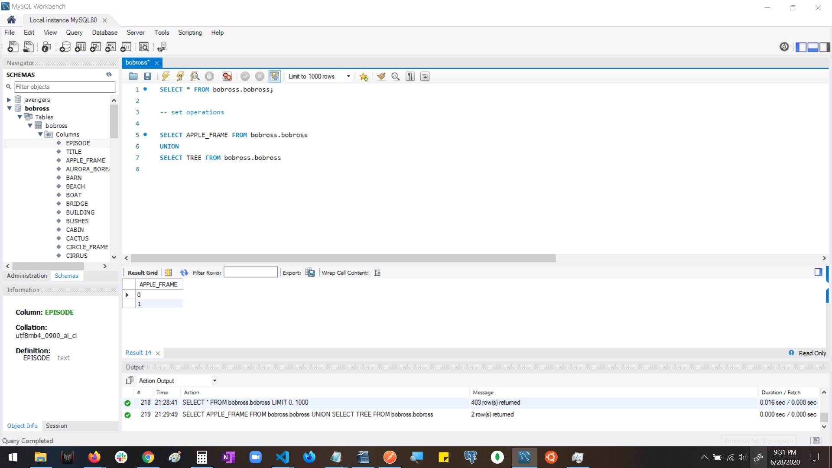

Query: SELECT APPLE_FRAME FROM bobross.bobross
UNION
SELECT TREE FROM bobross.bobross

Columns: 1

Expected rows: 1
Resource: https://www.mysqltutorial.org/sql-union-mysql.aspx/

-subqueries
Subqueries are queries that exist within the outer query. They are often used with WHERE statements which provide constrained results. They can be used with comparers such as WHERE, IN/NOT IN, EXISTS/ NOT EXISTS, and comparison operators(<, >, =, etc). Functions such as AVG, SUM, MAX are commonly used in subqueries.

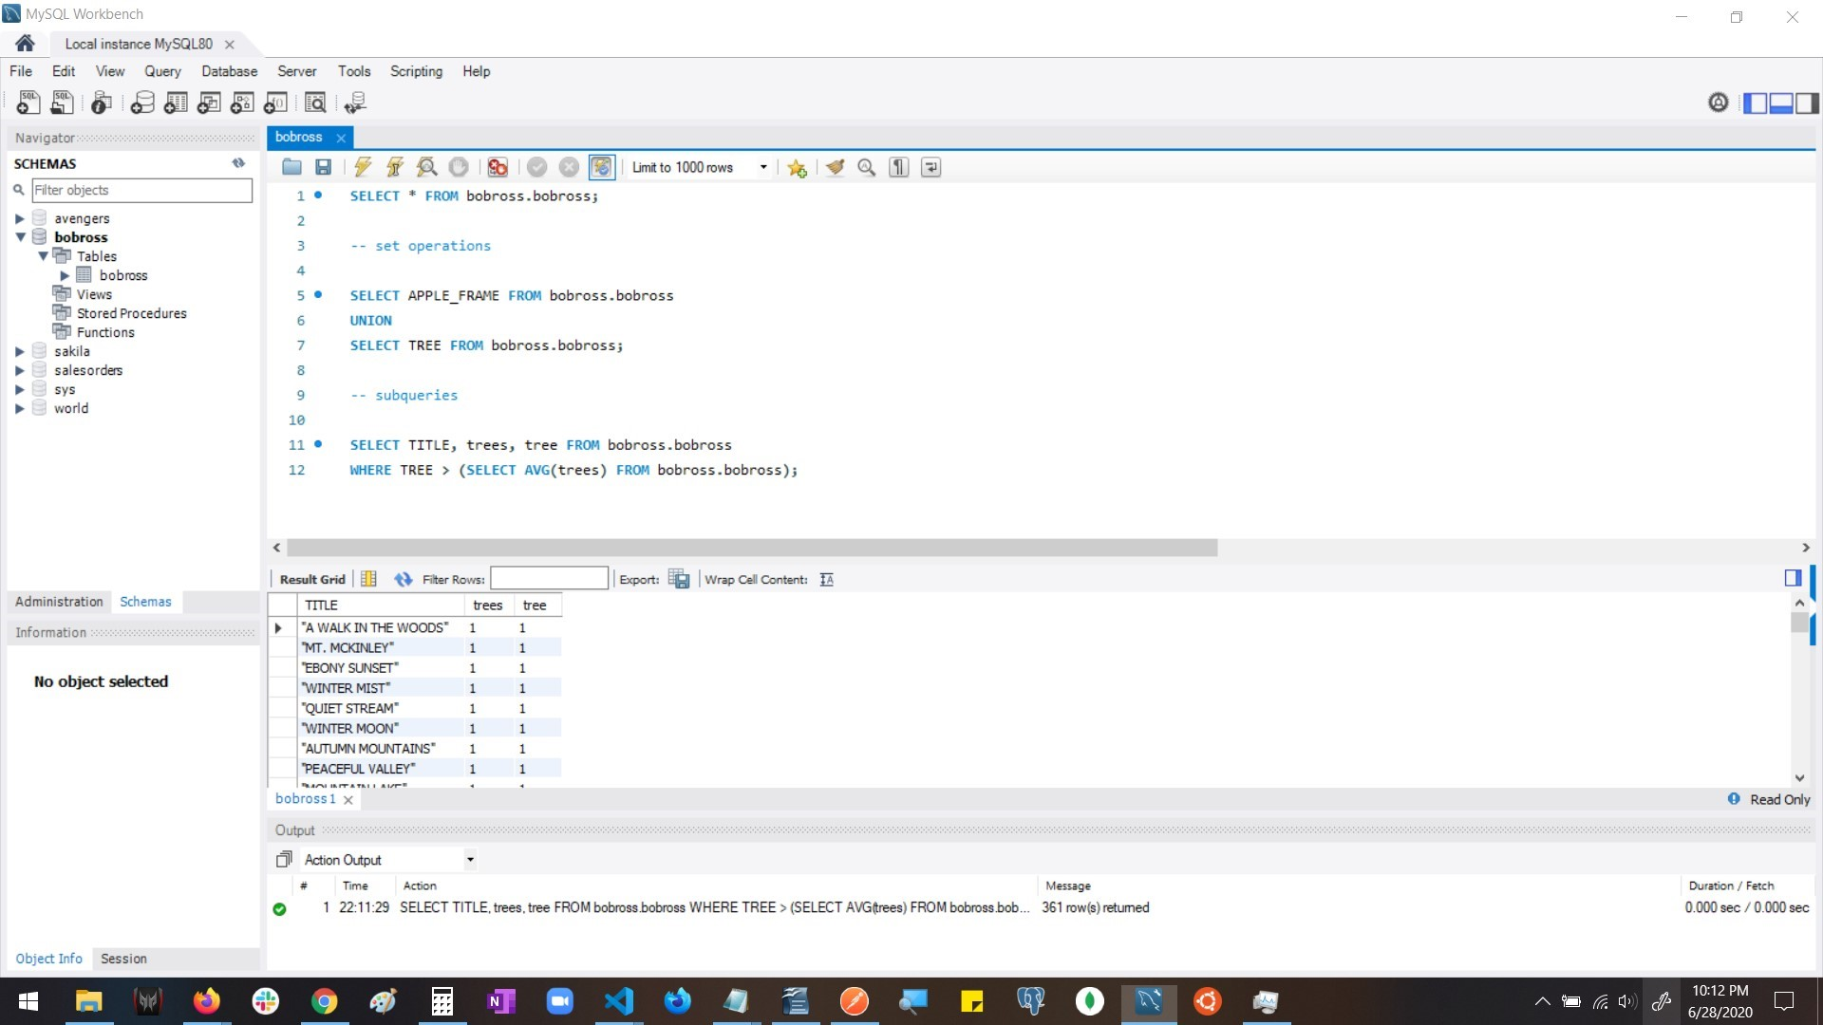

QUERY: SELECT TITLE, trees, tree FROM bobross.bobross
WHERE TREE > (SELECT AVG(trees) FROM bobross.bobross);

COLUMNS: 3

EXPECTED ROWS: 361

RESOURCE: https://www.mysqltutorial.org/mysql-subquery/

-order of operation of queries
The order of operations for queries is the following:
- FROM, including JOINs
- WHERE
- GROUP BY
- HAVING
- WINDOW functions
- SELECT
- DISTINCT
- UNION
- ORDER BY
- LIMIT and OFFSET
List from: https://www.eversql.com/sql-order-of-operations-sql-query-order-of-execution/
However, this list is not set in stone and is customized as needed to make data retrieval more efficient. The standard order of operations for queries, listed above, is used to provide accurate or specific results based on the criteria given.

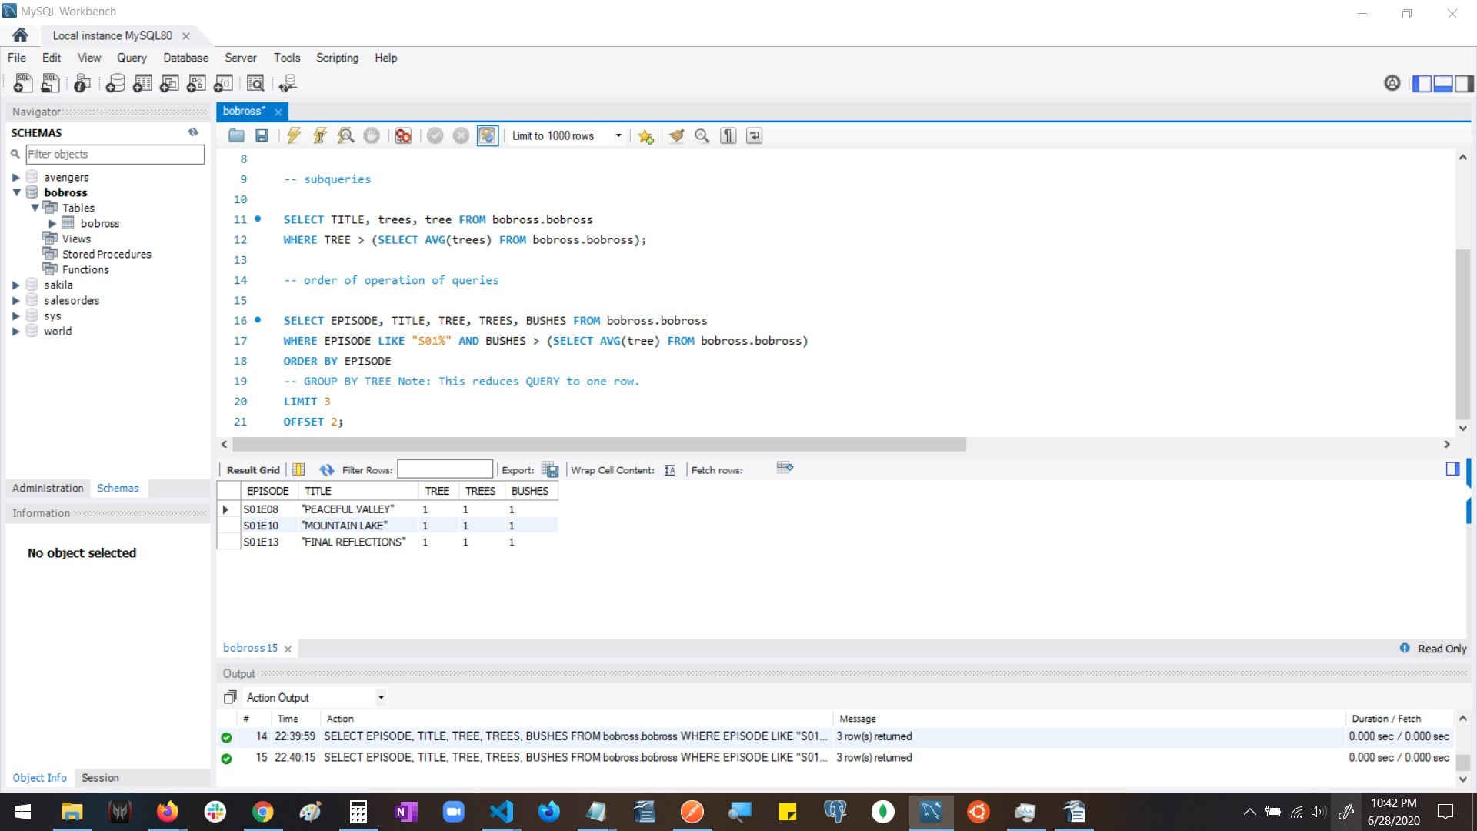

Query:SELECT EPISODE, TITLE, TREE, TREES, BUSHES FROM bobross.bobross
WHERE EPISODE LIKE "S01%" AND BUSHES > (SELECT AVG(tree) FROM bobross.bobross)
ORDER BY EPISODE
-- GROUP BY TREE Note: This reduces QUERY to one row.
LIMIT 3
OFFSET 2;

Columns: 5

Expected Rows: 3

Resource: https://www.eversql.com/sql-order-of-operations-sql-query-order-of-execution/

-creating, altering, and dropping tables

Create table: This function used to create tables. A table can have one primary key and is usually given one when creating a table, which must be kept unique(meaning no duplicate numbers or characters), which is usually given the auto-increment property. When creating a table, columns with names should be given along with their data type(INT, VARCHAR,BOOLEAN) and their corresponding values. INSERT INTO [table] (column_name) VALUES (value) is usually used after this to provide values to the table and its columns.
ALTER table: This allows you to modify a table based on certain criteria using the same statements you would use during an initial select. Alter is used to modify, add, or drop columns of data.
DROP table: This is normally used as a statement before creating a new table. This is because two tables of the same name can't exist, so an error would occur. Tables can also be dropped based on defined criteria.
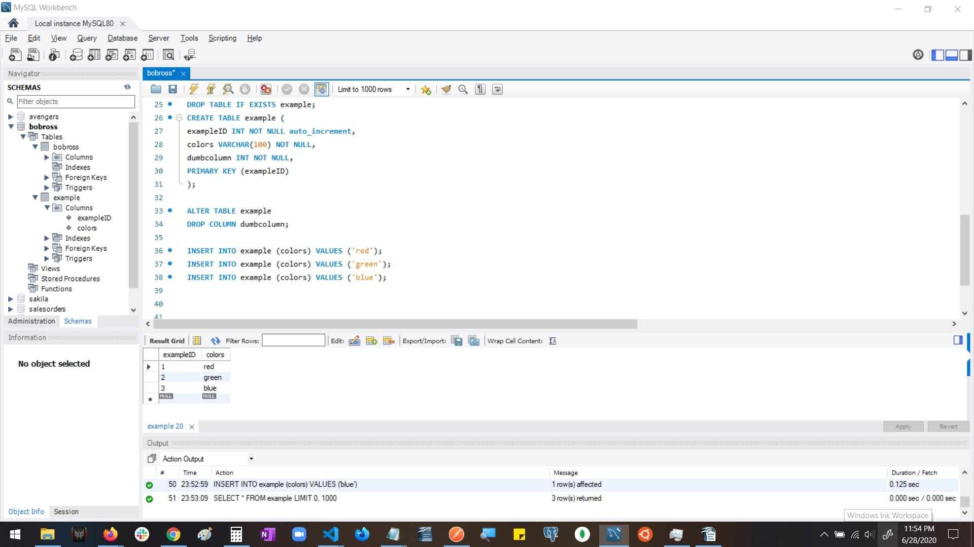

QUERY: DROP TABLE IF EXISTS example;
CREATE TABLE example (
exampleID INT NOT NULL auto_increment,
colors VARCHAR(100) NOT NULL,
dumbcolumn INT NOT NULL,
PRIMARY KEY (exampleID)
);
ALTER TABLE example
DROP COLUMN dumbcolumn;
INSERT INTO example (colors) VALUES ('red');
INSERT INTO example (colors) VALUES ('green');
INSERT INTO example (colors) VALUES ('blue');

COLUMNS: 3(then 2)
EXPECTED ROWS: 3
-associations
Associations are created via keys. The keys used are UNIQUE, PRIMARY, and FORIEGN keys. Each table can have one Primary key which is usually given auto-increment. A Unique key is intended to keep a column unique, this means no repeat values. What type of key a column may or may not have can be seen in the information section of mySQL. A key can be given either at the creation of the table or by altering the table. The image provided will show “exampleID INT AI PK” That PK indicates that the key is the primary key of that table.

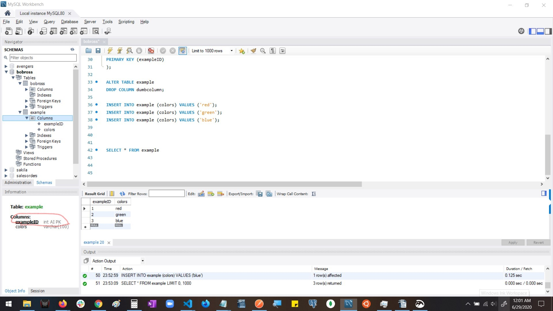

-joins and multiple table joins
Join is used to compare tables values. For example, if a table had a fruit table with a id column and a seller table had a id column, and they were both either unique or primary keys, then these 2 tables could be joined by JOIN tablename1 ON tablename2.id = tablename1.id. This would provide a table that would reflect these tables and their data. The bobross table does not have a unique or primary key at the moment, but I will be using the JOIN statement on its own, because that still functions. There's just not a key or enough data to do more at the moment.

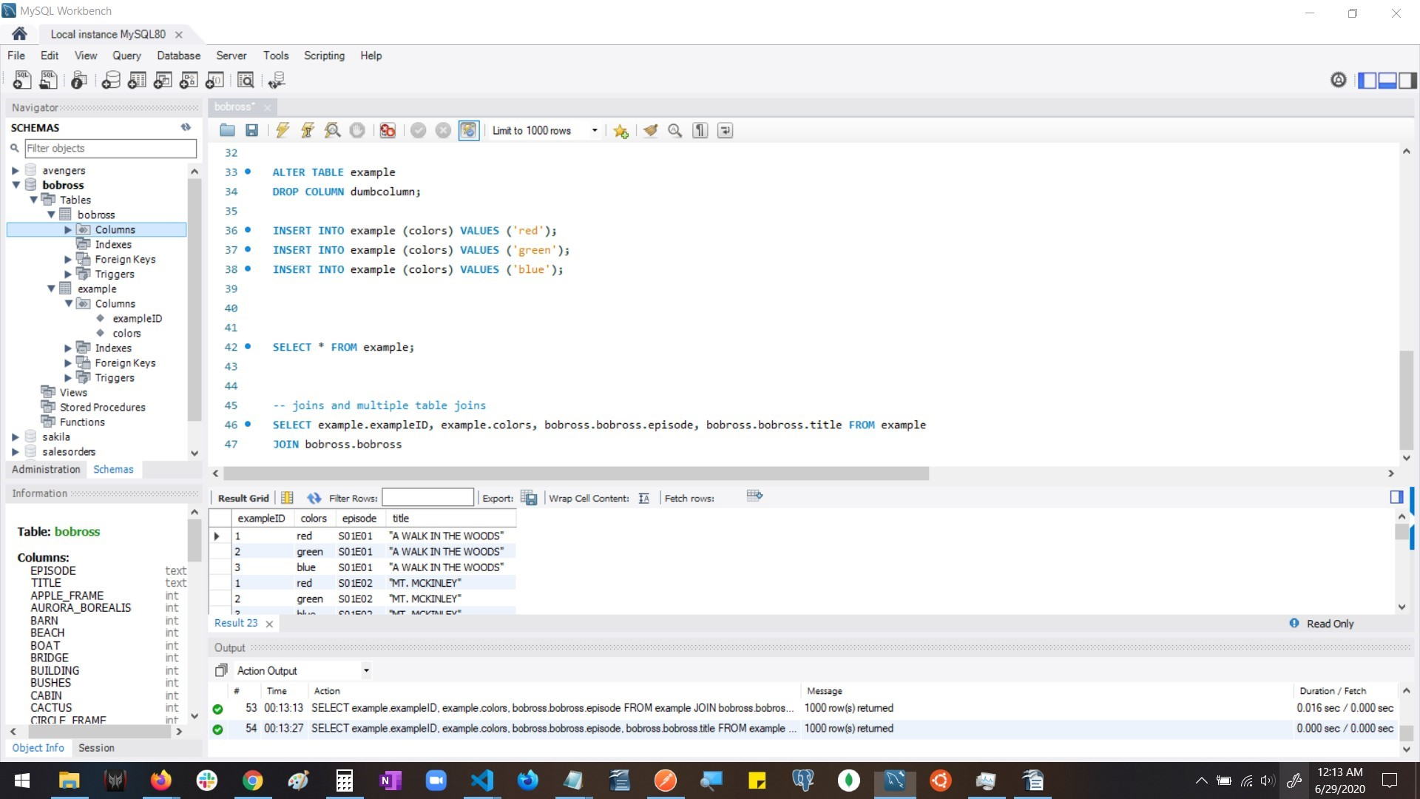

Query: SELECT example.exampleID, example.colors, bobross.bobross.episode, bobross.bobross.title FROM example
JOIN bobross.bobross

Columns:4

expected rows: 1000

